**Name:- Piyush Sunil Patil**

**Roll No:-143**

**Practical No:-7**

**Practical Name:-Use git branch to create a new branch and git checkout to switch to the branch.**

admin@DESKTOP-K3MVO4B MINGW64 ~

$ cd MCA

admin@DESKTOP-K3MVO4B MINGW64 ~/MCA (branch2)

$ git checkout main

Switched to branch 'main'

Your branch is ahead of 'origin/main' by 1 commit.

(use "git push" to publish your local commits)

admin@DESKTOP-K3MVO4B MINGW64 ~/MCA (main)

$ git init MCA

Reinitialized existing Git repository in C:/Users/admin/MCA/MCA/.git/

admin@DESKTOP-K3MVO4B MINGW64 ~/MCA (main)

$ git branch branch1

admin@DESKTOP-K3MVO4B MINGW64 ~/MCA (main)

$ git checkout branch1

Switched to branch 'branch1'

admin@DESKTOP-K3MVO4B MINGW64 ~/MCA (branch1)

$ touch MCA2.txt

admin@DESKTOP-K3MVO4B MINGW64 ~/MCA (branch1)

$ git add MCA2.txt

admin@DESKTOP-K3MVO4B MINGW64 ~/MCA (branch1)

$ git commit -m "First commit of branch first"

[branch1 e9eed8d] First commit of branch first

1 file changed, 0 insertions(+), 0 deletions(-)

create mode 100644 MCA2.txt

admin@DESKTOP-K3MVO4B MINGW64 ~/MCA (branch1)

$ git push -u origin branch1

Enumerating objects: 3, done.

Counting objects: 100% (3/3), done.

Delta compression using up to 4 threads

Compressing objects: 100% (2/2), done.

Writing objects: 100% (2/2), 232 bytes | 116.00 KiB/s, done.

Total 2 (delta 1), reused 0 (delta 0), pack-reused 0

remote: Resolving deltas: 100% (1/1), completed with 1 local object.

remote:

remote: Create a pull request for 'branch1' on GitHub by visiting:

remote: https://github.com/DhirajPatil129/MCA/pull/new/branch1

remote:

To https://github.com/DhirajPatil129/MCA.git

* [new branch] branch1 -> branch1

branch 'branch1' set up to track 'origin/branch1'.

**Before Pull and merge on remote repository:-**

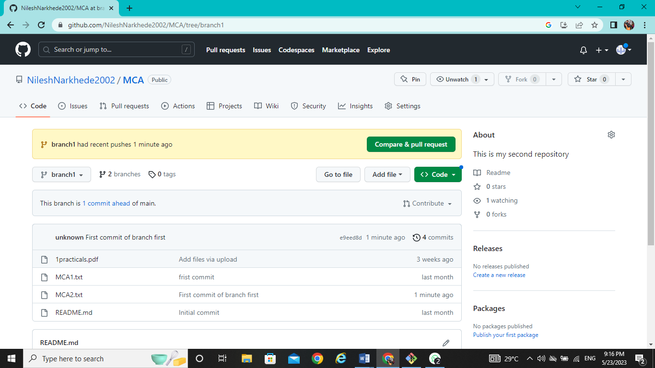

**Performing Pull request:-**

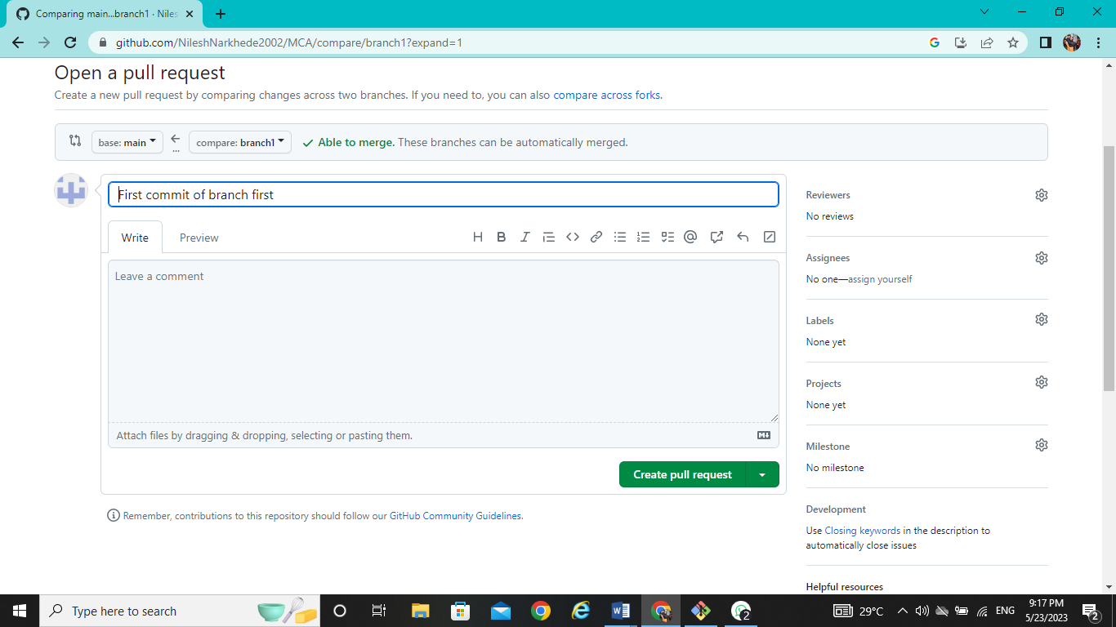

**After Pull performing Merge on remote repository at primary branch (main):-**

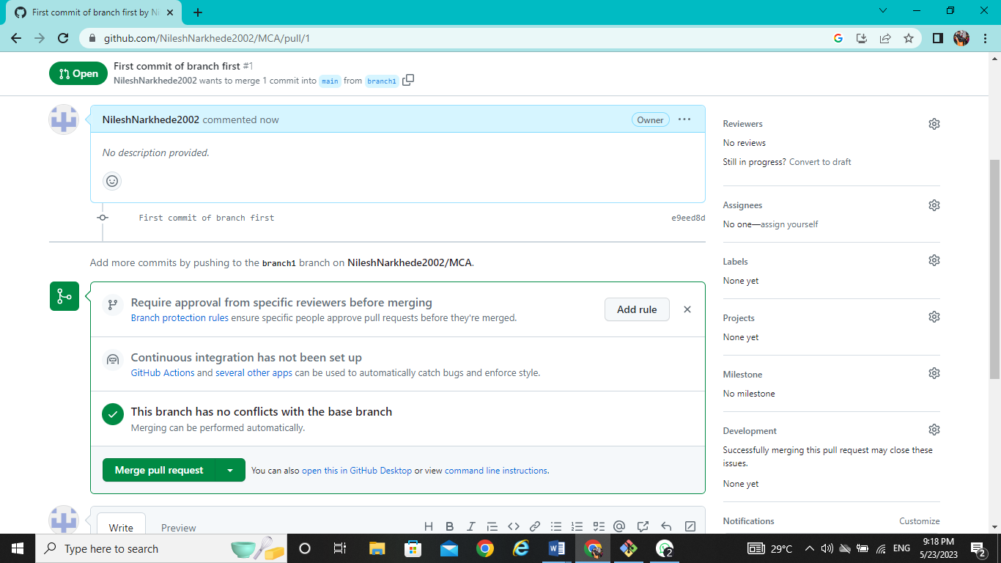

**After merge from firstbranch to primary branch (main) on remote repository:-**

